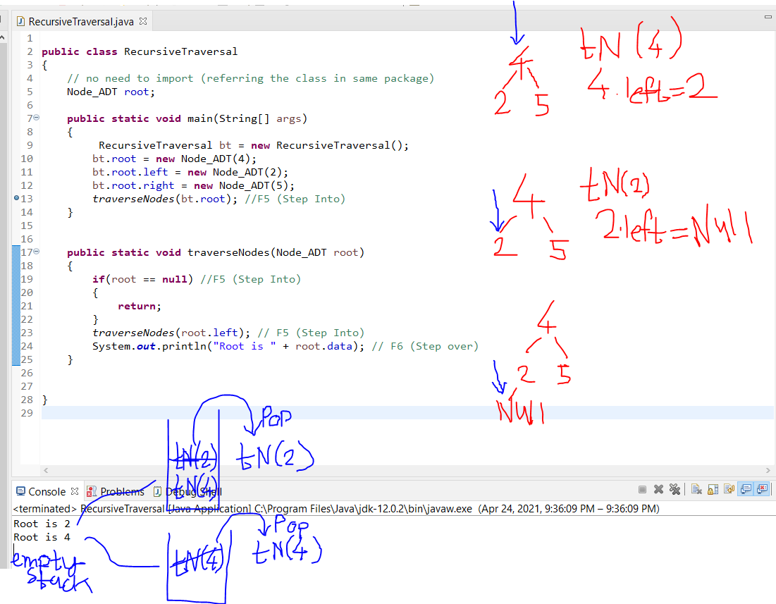

Head Recursion (Recursive call happens first)

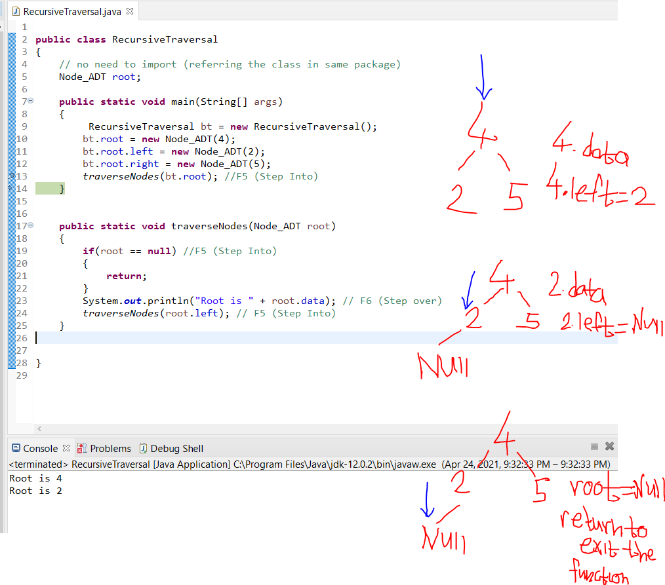

Tail Recursion (Recursive call happens last)